Effective communication

Being aware of the importance of being an effective communicator as a Board member will help you taking the most of the experience of being a Board member.

You need to think about:
What do you want to communicate?
How can you best get the message across?
What is the environment?
Who do you want to communicate to?
What is the timing?

Listening

Listening is more than the function of hearing. It is a process whereby you must focus on the message to understand it, analyse and evaluate the message before considering a response if necessary. Sometimes we listen better and more effectively than other times.

There are two types of listening: passive and active listening.

Passive or attentive listening is listening without reacting. It is allowing someone to speak, without interrupting and not doing anything else at the same time. Passive listening takes place when you focus on hearing and understanding the message with a genuine interest, but the listener does not follow-up with what they have been told i.e. fails to take action.

Active or reflective listening takes place when the listener is genuinely interested in what the speaker says, and when the listener verifies their understanding of the message with the speaker. Active listening is reacting or doing something that demonstrates you are listening and have understood. It is giving non-verbal cues to demonstrate you are paying attention for instance nodding, making eye contact and making facial expressions appropriate to what is being said. It is reflecting back the main points and summarising what has been said.

For the purposes of the review you will need to actively listen during interviews in order to hear fully what is being said, but to also critically evaluate the conversation and to be able to explore in more depth what you are being told.

There are different ways to practise active listening:

Mirroring
This is repeating back phrases or words the speaker uses. This shows the speaker that you have listened and it gives them a sense of recognition.

Paraphrasing
This is rephrasing or restating what you have heard in your own words to ensure that you have understood the content of the message. It give the speaker an opportunity to elaborate on or clarify what they are saying and might stimulate greater objectivity by the speaker.

Summarising
Summarising involves pulling together the main elements of the discussion and organising them so that they can be reviewed, confirmed or corrected.

Questioning

Questioning serves different purposes: it enables you to get a response to a query, but it can also help you to clarify an issue; or even prompt action in the person you ask the question of.

There are two types of questioning and they each will give you different outcomes.

Closed questions should invariably get a yes/no or facts as answers. For example, “Are you thirsty?” Closed questions are useful when you want very specific information; to establish agreement; or to check something before going any further.

Closed questions are not helpful when you want to invite people to talk about themselves and their experiences. They have the potential to stifle the free flow of a conversation. They can set up a balance of power where you pose the questions and the person feel they have to search for the ‘right’ answer.

Open questions elicit longer answers. They usually begin with what, why, how. An open question asks the respondent for their knowledge, opinion or feelings. "Tell me" and "describe" can also be used in the same way as open questions. For example, “What happened at the meeting?” “Tell me what happened next” “Describe the circumstances in more detail.”

Open questions can be answered in many different ways. They encourage people to:

- Clarify their thinking;
- Look at the assumptions they might be making;
- Look for the evidence behind the judgements they are making;
- Think about the implications of what they think, say and do;
- Consider other viewpoints or perspectives.

Open questions are not helpful when you want to draw the conversation to a close as they encourage further responses.

In a review you will be questioning people to elicit as much information as you can and you want to do this in a non-judgemental way. Careful questioning can make people feel comfortable to share with you more information than questions worded in such a way as to put them on the defensive.

Try to keep “why” questions to a minimum, especially if it’s in relation to a negative point in the review. "Why" questions are good for soliciting information, but can make people defensive so be thoughtful in your use of them e.g. “Why did you choose to…?”

Asking multiple questions at once can be confusing for the person responding. It can make them unsure of which question to answer first, but it also gives them the opportunity to avoid answering the questions they would rather not answer. By asking more than one question at a time, you are not likely to get the information you are looking for. Ask questions one by one, particularly if they are long.

Leading questions suggest the answer or contain information leading to the desired answer.
When you ask a leading question you are directing the person to respond in a certain way which might not be helpful in that you might not get all the relevant information. By asking leading questions, you are directing the answer to an answer you want, as opposed to a genuine answer e.g. “Shouldn’t you have taken into account…?”

Asking purposely challenging questions can be seen as confrontational or critical and are likely to result in the person becoming defensive and less likely to freely provide information.
If you purposely challenge with difficult questions, you are not likely to get the in-depth information that you are seeking e.g. “Was that not something you should have done differently?”

Feedback

Providing feedback is an important part of being a Board member but how do you provide it effectively? sparqs has developed the A, B, C, D of effective feedback to help you do so. Below we explain each element and how they contribute to providing effective feedback.

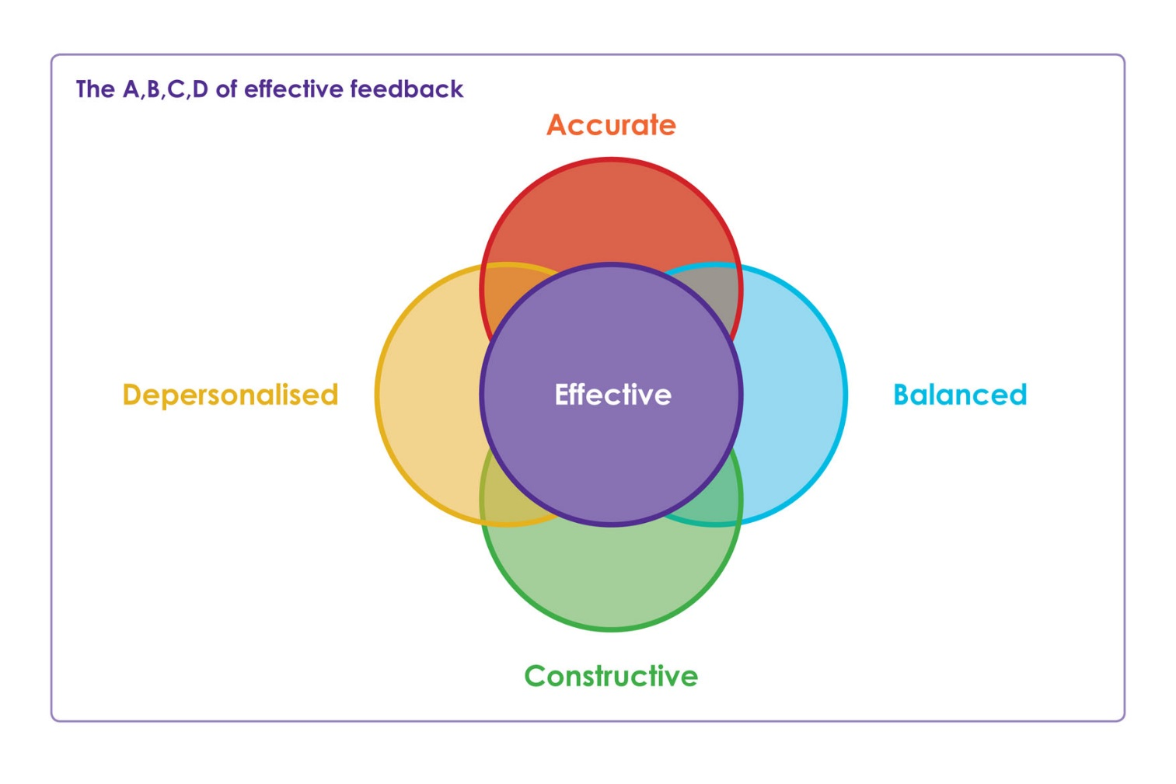
Accurate: When commenting on the learning experience, be specific, and provide evidence for what you are saying. Avoid sweeping generalisations or emotional language. If you have a survey that tells you 67% of people don’t like the feedback they receive, don’t tell staff that 97% don’t like it.

Balanced: Don’t just pass on negative comments to staff, even if that is mostly what you are hearing from students. Say positive things too. This helps soften the blow and makes you look more professional.

Constructive: You are not just here to identify the problems; you are also here to help find a solution too. If you raise an issue, make a suggestion at the same time- this also helps you to look professional.

Depersonalised: Even if students think that a member of staff has done something wrong, it’s always hard to make or receive personal comments. Try not to mention anyone by name in meetings, talk about the class and the impact on the learning experience.

Facilitation

You may be responsible for chairing some of the sessions during meetings. You will therefore have to facilitate discussions with a range of people to ensure that you get a good picture of their views.

A facilitator’s role is to support and enable the discussion, ensuring everyone who wants to contribute can. They manage the discussion while following the agenda and keeping to time. It can be a challenging role and you will need to juggle a lot of things at once.

Here are some essential points to bear in mind when you facilitate discussions:

Keep to time
The time you will have for the session will not be as long as you would like and you will have a lot to fit in. you will need to involve the other panel members in the questioning and ensure everyone gets the chance to speak. Remember to use closed questioning to draw questioning to a close.

Stay neutral
As a review team member it is important to stay neutral but it is particularly important as a facilitator to ensure that you are perceived to be biased.

Focus
It will help if you keep to the agenda. Use your questioning skills to bring people back to the point if they stray and don’t be afraid of (politely) reminding them of the original question.

Stimulate and encourage responses
It is your responsibility as facilitator to ensure everyone feels comfortable to participate. This is especially important when talking to the student group as some students might not feel comfortable to speak in front of a group, so do your best to ensure the environment is conducive to students feeling comfortable talking. Your listening and questioning skills will be valuable here.

Regulate
Try to avoid letting the same people speak all the time, you need to get as broad an input as possible. As facilitator you are responsible for managing the discussion and should ensure everyone that wants to contribute can.

Tips for effective communication

- Keep good eye contact during conversations.
- Be aware of your body language. Try to keep it open to show that you are interested.
- Avoid negative mannerisms.
- Be attentive. Try nodding, smiling or making small agreeing noises.
- Keep an open mind to what you are hearing.
- Don’t interrupt to impose your solutions on the speaker.
- Clarify your understanding with the speaker.
- Pay attention to the response and let the person completely finish what they have to say.
- Pay attention to non-verbal cues e.g. signs of discomfort or tension.
- Speak slowly and clearly and be consistent.
- Take notes and clarify any points that have not been understood.

